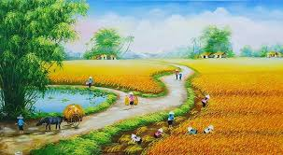

<https://tranhsondautranphu.com/tranh-phong-canh-dong-que/>



<https://binhluc.hanam.gov.vn/Pages/niem-vui-duoc-mua.aspx>



<https://dhbdesign.vn/ve-cay-tre/>



<https://vi.pngtree.com/freepng/vietnamese-young-woman-wearing-traditional-dress-ao-dai-and-a-conical-hat_15091389.html>



<https://vn.pikbest.com/png-images/mid-autumn-festival-vietnam-cartoon-illustration-lotus-mountain-moon-lion-dance-mid-autumn-blessings-web-banner_10708843.html>



<https://www.behance.net/gallery/75664305/Tt-Doan-Vien-Vietnamese-New-Year>



<https://www.freepik.com/free-vector/hand-drawn-tet-illustration_22111642.htm>



<https://cdmetuchen.org/php/index.php?menu=sinhhoat&sub=tet&id=3907>

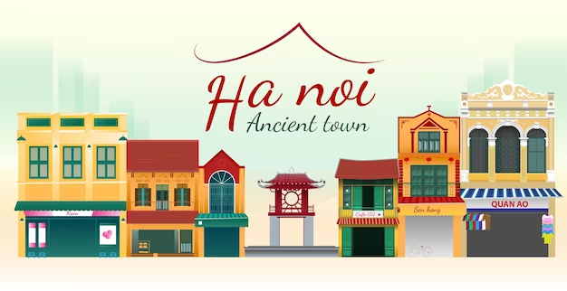

<https://www.freepik.com/premium-vector/hanoi-ancient-street_26566797.htm>

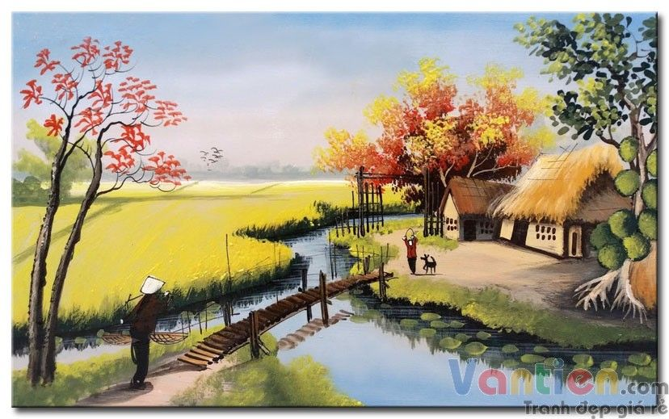

<https://www.pinterest.com/pin/88523948904691182/>

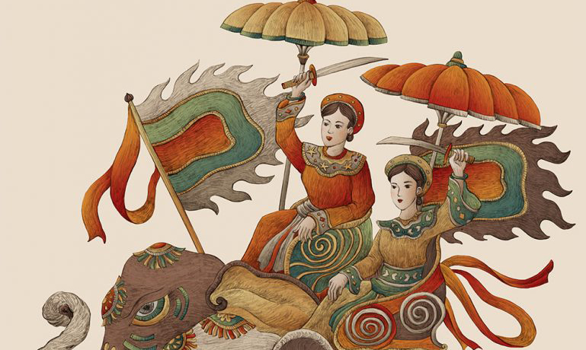

<https://vnexpress.net/tranh-hai-ba-trung-tren-dong-ho-thuy-si-bi-nghi-dao-hoa-si-viet-4613961.html>



<https://www.freepik.com/vectors/ho-chi-minh>



<https://pngtree.com/freepng/cartoon-portrait-of-vietnam-national-day_6574104.html>



<https://pngtree.com/freepng/vietnam-national-day-cartoon-characters-celebrating_6574109.html>



<https://www.freepik.com/premium-vector/cute-little-girl-watercolor-paint_44322961.htm>

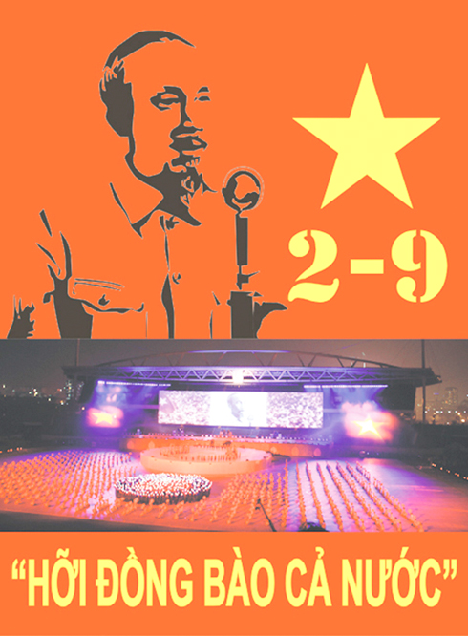

<https://baokhanhhoa.vn/van-hoa/201709/dau-an-ngay-doc-lap-trong-tho-viet-nam-8051726/>



<https://vi.pngtree.com/free-png-vectors/ng%C6%B0%E1%BB%9Di-l%C3%ADnh-vi%E1%BB%87t-nam>

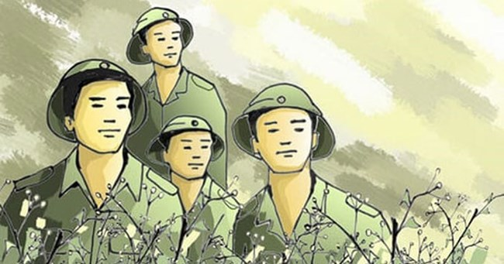

<https://vov1.vov.gov.vn/tam-tinh-bien-gioi-va-hai-dao/nhung-nguoi-linh-quan-doi-nhan-dan-viet-nam-giu-binh-yen-mua-xuan-cho-nhan-dan-c61-66905.aspx>



<https://tinhocnews.com/vector-bo-doi-viet-nam/>

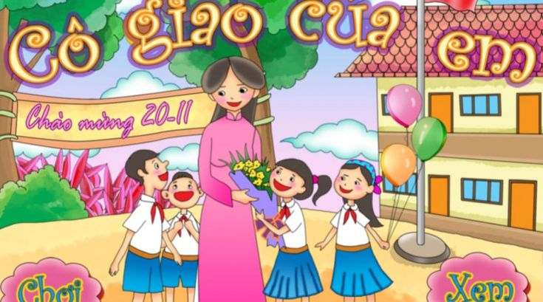

<https://www.pinterest.com/pin/582231058048529518/>



<https://download.vn/nghi-luan-xa-hoi-ve-vai-tro-cua-nguoi-thay-41228>



<https://free.vector6.com/vector-lang-chu-tich-viet-nam-2/>

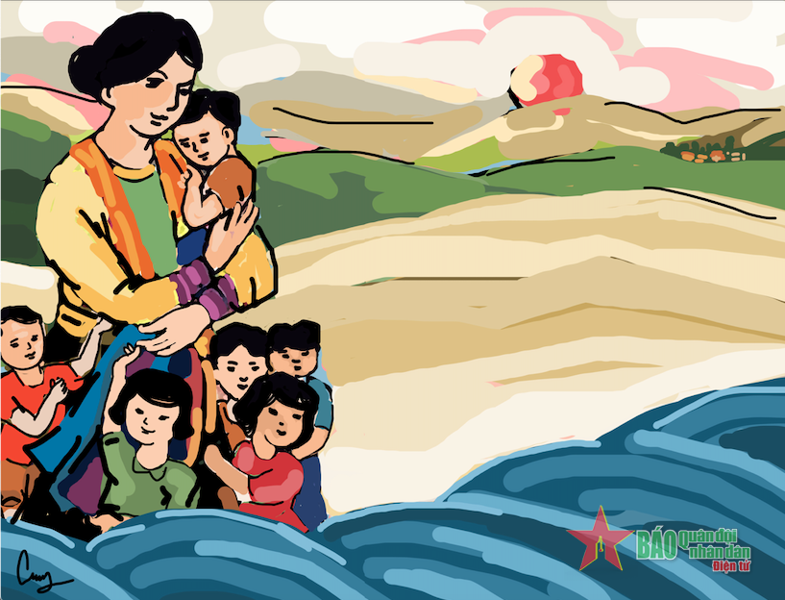

<https://baohaiquanvietnam.vn/tin-tuc/menh-mang-bien-va-me>

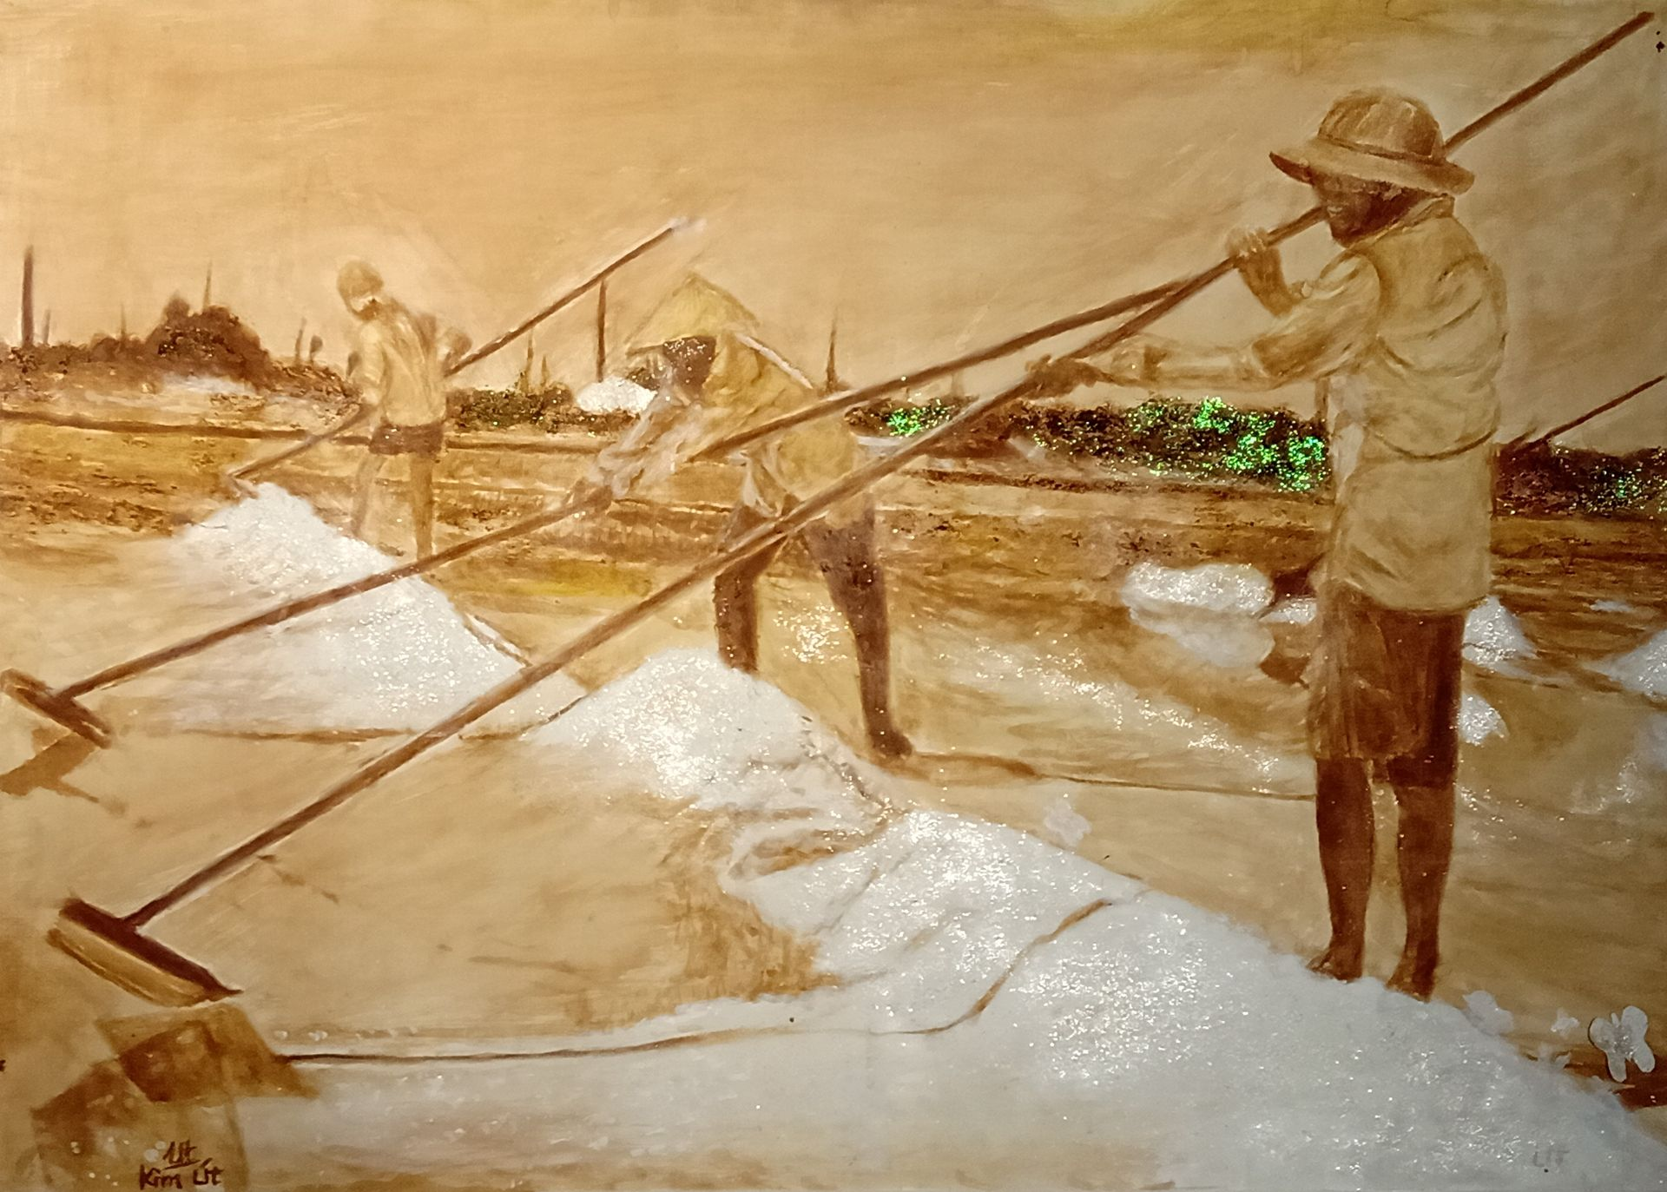

<https://indochineart.vn/tac-pham/hoi-hoa/canh-dong-muoi~1741>



<https://chaohanoi.com/2020/06/05/the-names-behind-the-hanoi-streets-lac-long-quan-and-au-co/>

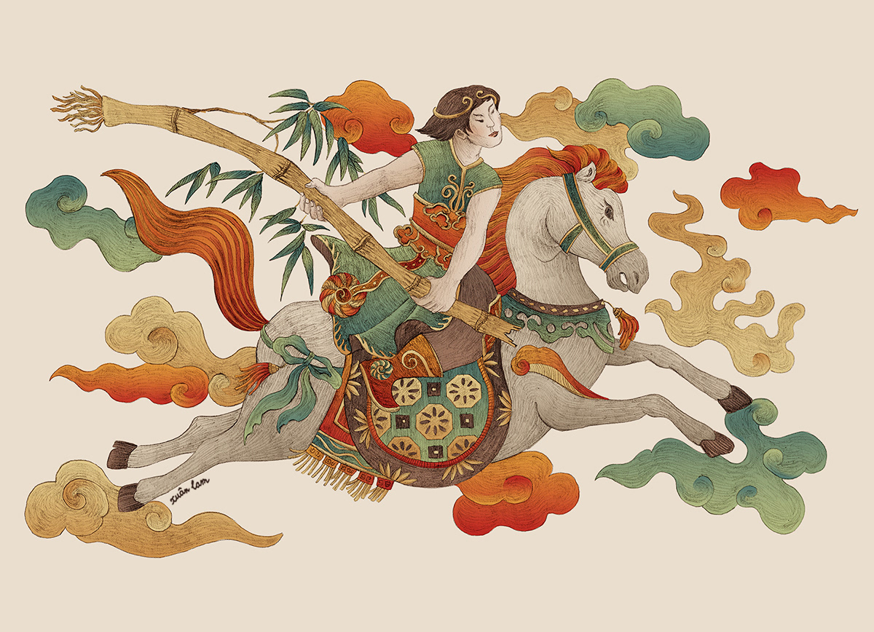

<https://www.behance.net/gallery/51227681/Folk-Paintings-The-Remake-%282016-2019%29/modules/546820157>

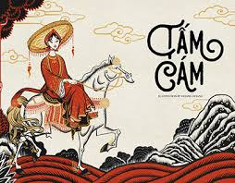

<https://www.behance.net/search/projects/tam%20cam%20>

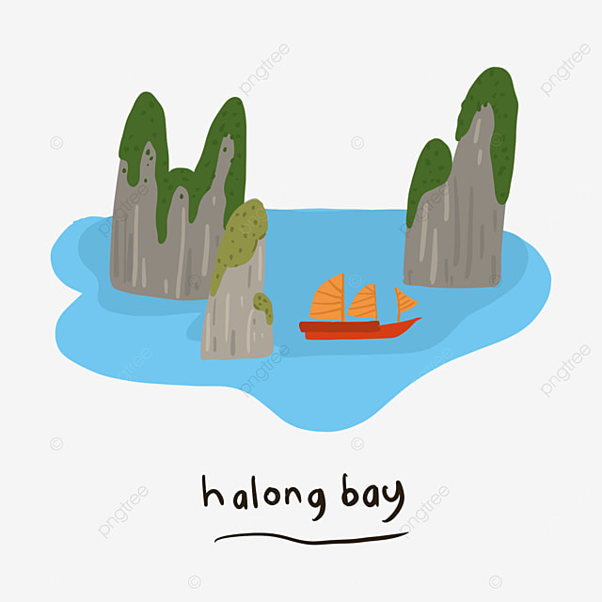

<https://vi.pngtree.com/freepng/illustration-of-halong-bay-vietnam-popular-destination_6066564.html>

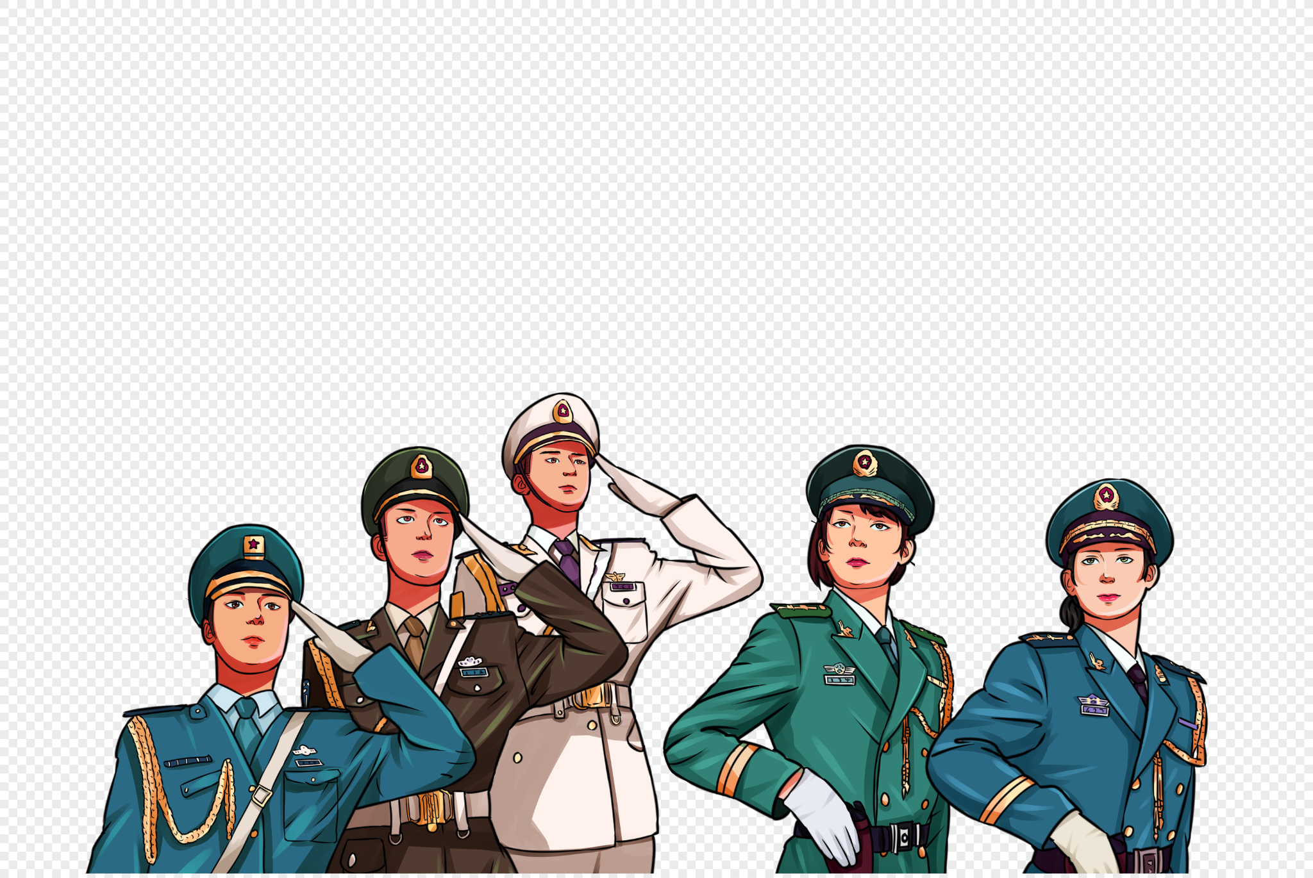

https://vn.lovepik.com/images/png-the-military.html